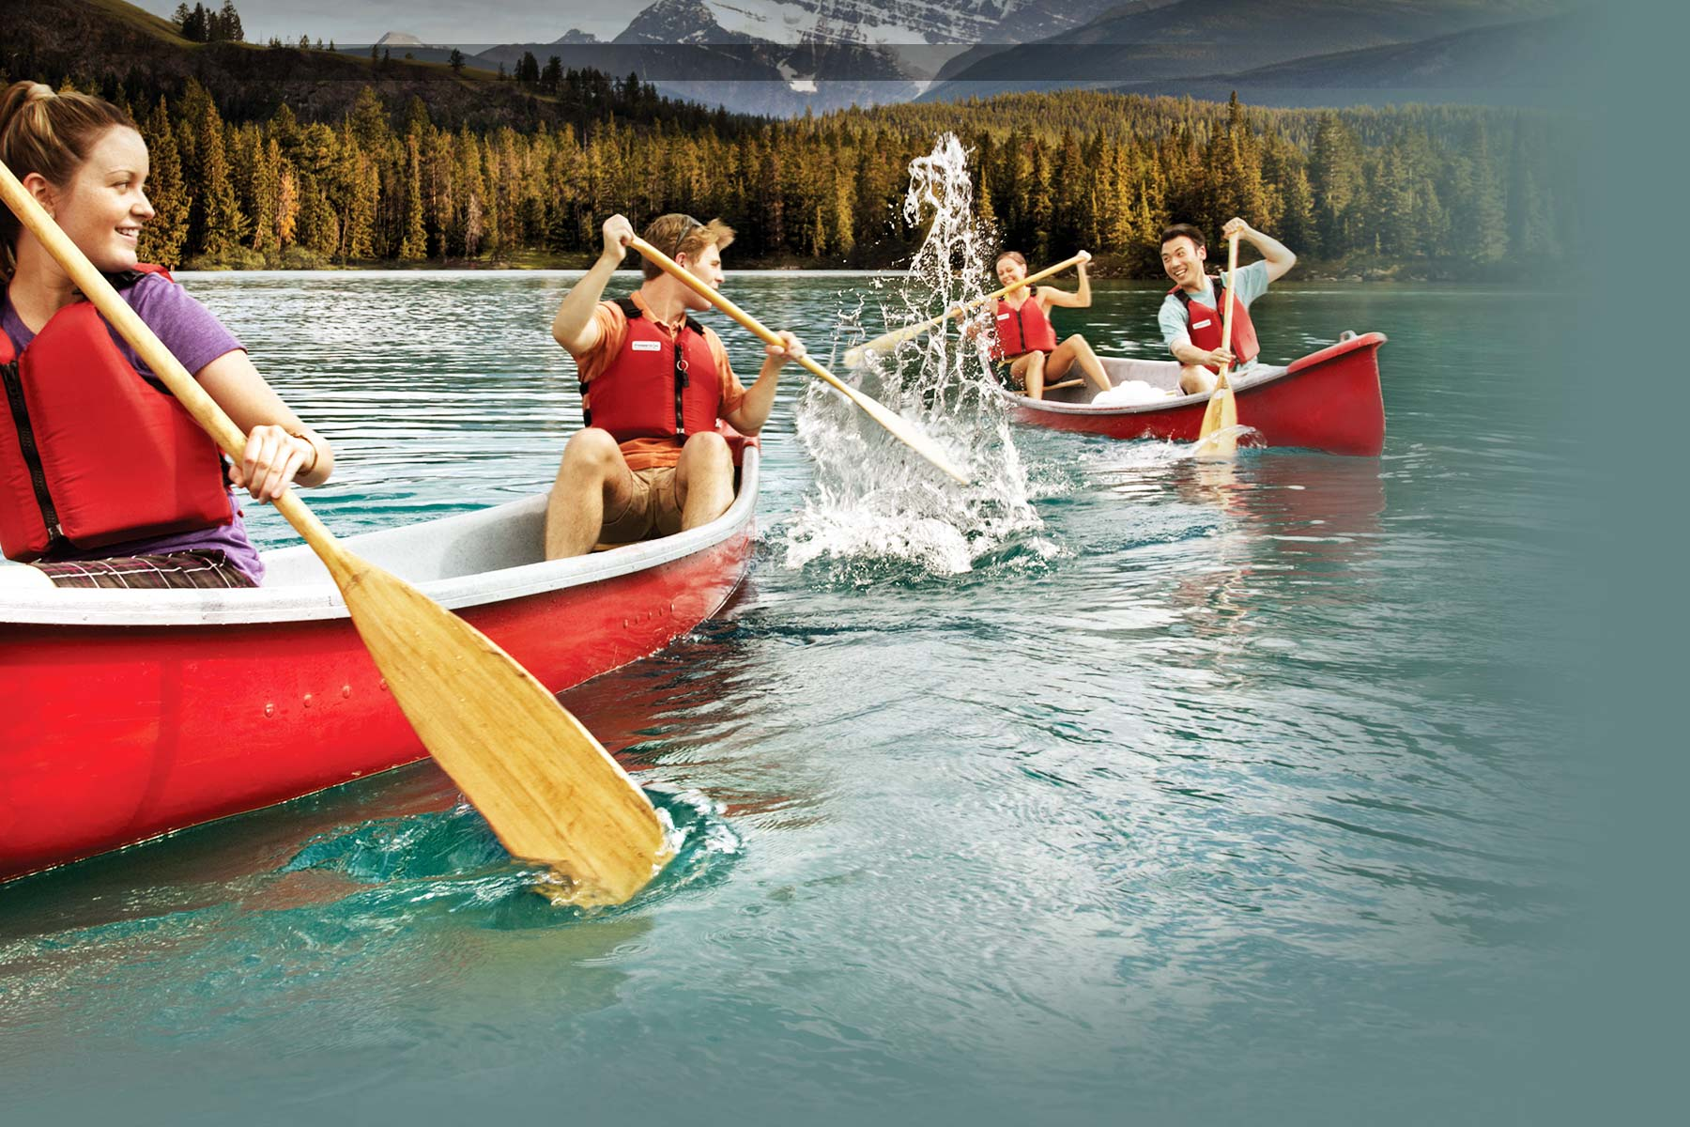Canoeing Basics

FREE CLASS

***Class runs from 9am to 11am. We will cover basic paddling strokes and what to do when you flip over.***

The park will supply boats, pfds, and paddles.

What to bring?

* Sunscreen, sunglasses, and a hat
* Wear clothing you plan to get wet in and your feet must have shoes or sandals on them
* Water bottle full of water

**Ages 13-15** (must be accompanied by an adult**), 16-17** (must have adult sign a waiver if the parents aren’t staying). **18 and up** can sign the waiver yourself.

CALL THE BOAT HOUSE BETWEEN 10am and 5:30pm at **704-984-6160** or visit the boathouse in person to register.

Paddling Class Sign Up

CANOE/KAYAK

Date:

1. Age
2. Age
3. Age
4. Age
5. Age
6. Age

Instructor:

Jason Murvine

Co-instructor